Chapter 3: Nationally determined contributions and long-term pledges: The global landscape and G20 member progress
Lead authors: Takeshi Kuramochi (NewClimate Institute, Germany), Taryn Fransen (World Resources Institute, United States of America), Michel den Elzen (PBL Netherlands Environmental Assessment Agency, the Netherlands) [POSSIBLY ANOTHER LA] [ORDER TBD]

Contributing authors: Saritha Vishwanathan (IIMA/Kyoto University), other contributors tbc
Data contributors: Modelling teams (CAT, PBL, JRC, possibly those from the Scenario Compass Initiative if the data become available), progress tracking organisations (Climate Watch, IEA? OECD?)

Introduction

Characteristics and impact of new NDCs

Do NDCs reflect best-practice characteristics?
- This section responds to the request in the content note to address the question: “To which extent do the new NDCs (globally and for the G20) reflect and contribute to achieving key milestones for 2030 and 2035, including global stocktake outcomes, and to progress in other important criteria (economy-wide, all GHGs, progression compared with previous NDC, etc.)?”
- We propose to build on last year’s Tables 3.1 and 3.2, which address many of the key characteristics noted in the Content Note and on p. XXI of last year’s EGR
- We are exploring the feasibility of addressing additional factors mentioned in the Content Note and on p. XXI of last year’s EGR, including NDCs’ explanation of how the NDC contributes to fair share, highest possible ambition, and 1.5°C; how it represents a progression from the last NDC; and further details on conditional elements.
- These tables, collectively, would respond to the request in the Content Note for a “structured mapping and table.”
- Table 3.1 could be revised into a figure to highlight progress since the Paris Agreement in 2015, responding to the guidance in the Content Note to facilitate this comparison.
Table 3.1 Evolution of NDC characteristics since the adoption of the Paris Agreement at COP 21
NDC characteristics | COP 21 (2015) | COP 26 (2021) | COP 27 (2022) | COP 28 (2023) | COP 29 (2024) | EGR 2025
Number of NDCs: | Number of NDCs (% of global emissions incl. LULUCF)
That reduce 2030 emissions relative to initial NDCs | N/A | 65 (63%) | 79 (79%) | 82 (80%) | 83 (80%)
That contain a GHG reduction target | 122 (85%) | 143 (89%) | 147 (91%) | 148 (91%) | 148 (91%)
That contain a GHG reduction target relative to a base year | 35 (33%) | 43 (34%) | 44 (34%) | 46 (35%) | 46 (35%)
That contain a GHG reduction target relative to a baseline scenario | 74 (19%) | 84 (19%) | 87 (21%) | 87 (20%) | 87 (20%)
That contain a GHG intensity target | 7 (32%) | 7 (33%) | 7 (33%) | 5 (32%) | 5 (32%)
Target coverage
That contain a GHG target covering all sectors (energy; industry; waste; LULUCF) | 46 (44%) | 80 (53%) | 85 (55%) | 88 (55%) | 89 (55%)
That contain a GHG target covering at least CO₂, methane and nitrous oxide | 99 (53%) | 125 (57%) | 130 (58%) | 132 (58%) | 132 (58%)
That contain a GHG target covering all GHGs listed in the Kyoto Protocol (CO₂, methane, nitrous oxide, hydrofluorocarbons, perfluorocarbons, sulfur hexafluoride and nitrogen trifluoride) | 20 (29%) | 22 (30%) | 23 (31%) | 23 (31%) | 23 (31%)
Conditionality
That are fully conditional | 45 (12%) | 34 (12%) | 32 (12%) | 33 (12%) | 35 (12%)
That are fully unconditional | 30 (58%) | 36 (62%) | 34 (62%) | 34 (61%) | 34 (61%)
That contain both conditional and unconditional elements | 78 (20%) | 96 (21%) | 101 (21%) | 101 (21%) | 99 (21%)
Note: Some NDCs contain more than one type of GHG target
Table 3.2 Number of NDCs containing measures related to global stocktake outcome
Global effort (paragraph of global stocktake outcome) | Number of NDCs containing related measures (Climate Watch 2024a)
Tripling renewable energy capacity by 2030 (28a) | 152
Doubling global average annual rate of energy efficiency improvements by 2030 (28a) | 142
Accelerating efforts towards the phase-down of unabated coal power (28b) | 42
Accelerating efforts globally towards net-zero emission energy systems (28c) | 151
Transitioning away from fossil fuels in energy systems (28d) | 27
Accelerating zero- and low-emission technologies, including, inter alia, renewables, nuclear, abatement and removal technologies (28e) | 151
Accelerating the substantial reduction of non-CO₂ emissions globally (28f) | 83
Accelerating the reduction of emissions from road transport (28g) | 139
Phasing out inefficient fossil fuel subsidies (28h) | Data not available
Conserving, protecting and restoring nature and ecosystems towards achieving the Paris Agreement temperature goal, including through enhanced efforts towards halting and reversing deforestation and forest degradation by 2030, and other terrestrial and marine ecosystems acting as sinks and reservoirs of GHGs (33) | 116

----------------- TEXT BOX ON AFRICAN UNION MEMBER STATES’ NDCs: STARTS ---------------------
- Here we provide stats for AU member states similar to Tables 3.1 and 3.2
----------------- TEXT BOX ON AFRICAN UNION MEMBER STATES’ NDCs: ENDS-----------------------

Impacts of new and updated NDCs on global GHG emissions in 2030 and 2035
- The additional reductions of the new NDC submissions (end of February 2025) is about 1.4 GtCO₂e [1.1;1.7] GtCO₂e compared to the 2030 emissions levels induced from the NDCs submitted by 1 September 2024.
- The implication of the US withdrawal from the Paris Agreement is that when the withdrawal takes effect (on January 27, 2026), the NDC will no longer be operative, which would reduce the additional reduction to 0.6 [0.5;0.7] GtCO₂e. [this is not the full story, as if we replace the NDC by the current policies scenario, the latter may still show a decrease compared to US 2030 GHG levels]
- The implications of the US withdrawal on the global NDC ambition will be discussed here.
- [Idea] Pre-peak countries: provide new insights into the anticipated peak year under the new NDCs

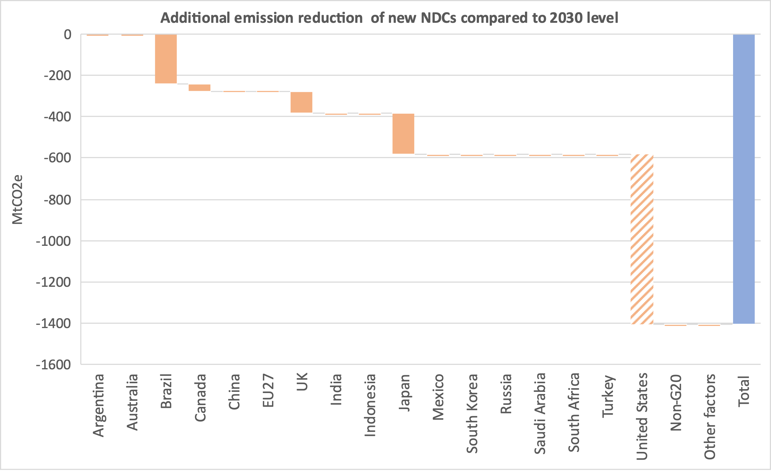
Figure 3.4 Impact of new and updated unconditional NDCs on 2035 global emissions compared to the 2030 levels of the NDCs. For countries with no new NDC submissions, a zero impact is assumed.

Progress of G20 economies towards NDCs
- The section responds to the content note “Are G20 members on track to achieving their 2030 and 2035 pledges?”
- The challenge here is for 2035: It’s likely that only a few modelling teams would provide both current policy projections and new NDC scenario projections.
- There seems to be an agreement that we will not have a policy developments subsection this year.

2030 NDC implementation status
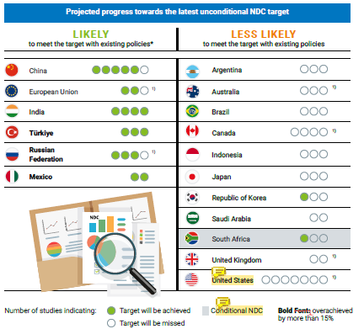
Figure 3.1 Assessment of progress towards achieving the 2030 NDC targets

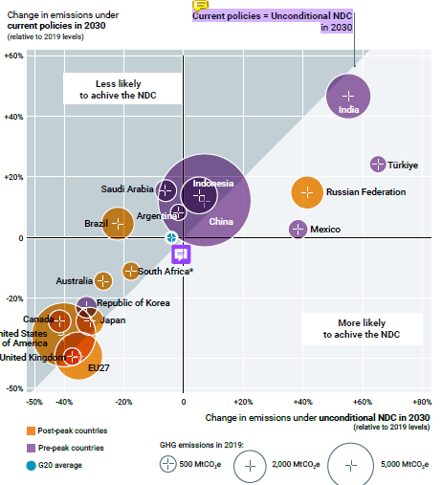
Figure 3.3 The landscape of 2030 NDC targets and implementation gaps for the G20 members collectively and individually by 2030, relative to 2019 emissions

Per capita emissions in 2030 and 2035
- Suggest adding 2035 NDCs to the figure from last year
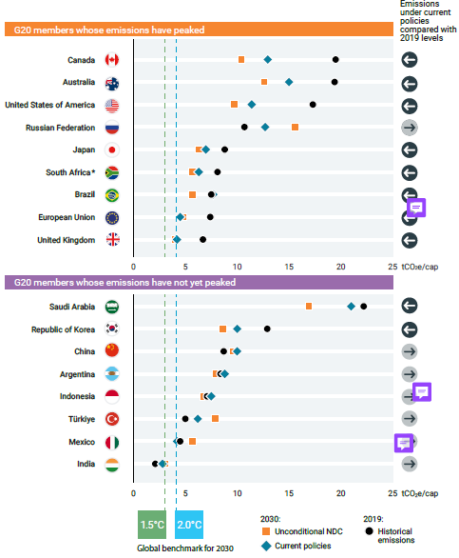Figure 3.4 G20 member per capita emissions (including LULUCF) implied by current policies and NDCs (both 2030 and 2035), compared with 1.5°C-consistent global average levels

NDC trajectories towards peaking and net zero

Global developments in long-term and net-zero pledges
- Short section presenting updated statistics of LT-LEDS and NZ pledges at the global level, following the structure of previous years’ reports: Legal form, scope/coverage, use of international market mechanisms, and separate targets for gross emission reductions and carbon removal
- There are approximately 5 new net-zero targets and 2 new LT-LEDS since last year’s report (to date)

Implementation details on G20 members’ net-zero pledges
- Short section presenting an updated table on G20 members’ NZ/LTS pledges robustness, following structure of previous years’ reports
- A key update will be for Mexico, which now for the first time has a net-zero target
Last year’s figure 3.4 is provided for illustrative purposes:
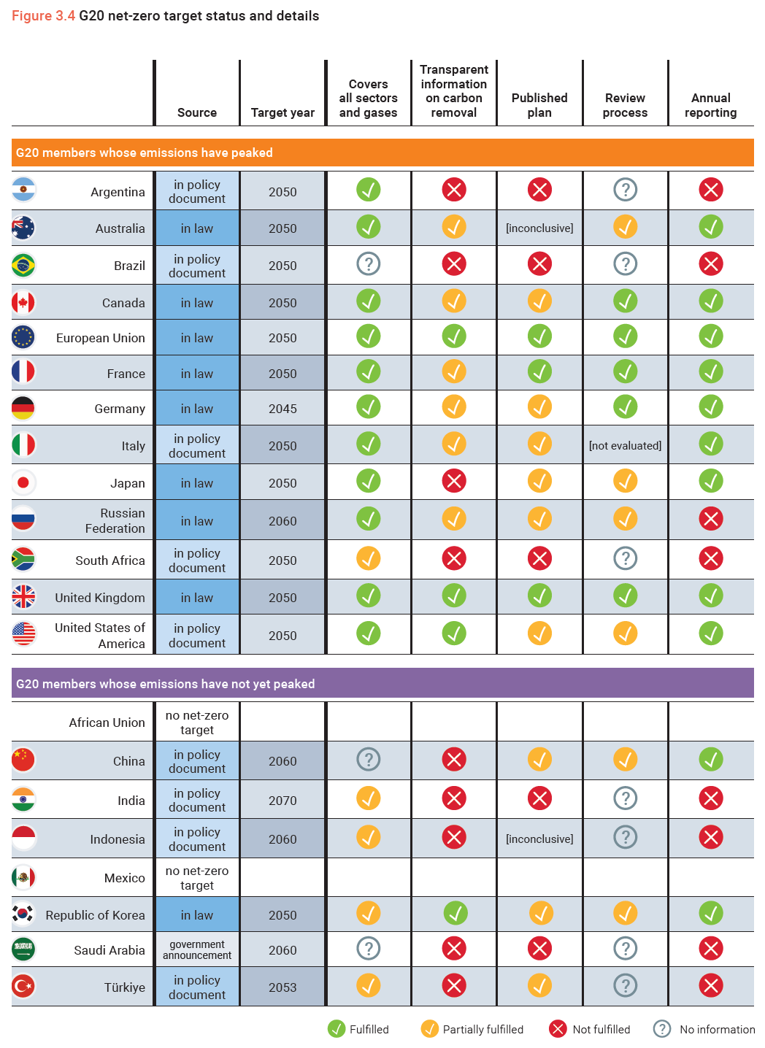

Implications of G20 NDCs and long-term pledges for peaking and net zero
- Responds to the content note: "Do the new NDCs present progress in terms of alignment with LEDS and net-zero pledges (potentially include G20 diagrams along the lines of previous EGRs)?"
- The analysis will follow a similar approach as in last year’s report, with revisions to improve robustness and accommodate new 2030 targets:
  - Chapter 2 will now present various approaches to determining countries’ peaking status. Chapter 3 will use the categorization approach from Chapter 2 that is most appropriate for comparison with net-zero targets, referring to Chapter 2 for additional information and nuance.
  - The section on countries that have already peaked will include an additional rate of change column, so there will now be 3: 2019-2030, 2030-2035, and 2035-net zero target year.
  - The section on countries that have not yet peaked will incorporate new information on post-2030 peaks, informed by Section 3.2.1.
  - We will strengthen the delineation between net-zero targets that cover all sectors/gases versus those that cover only a subset of sectors/gases.
Last year’s figure 3.5 is provided for illustrative purposes:
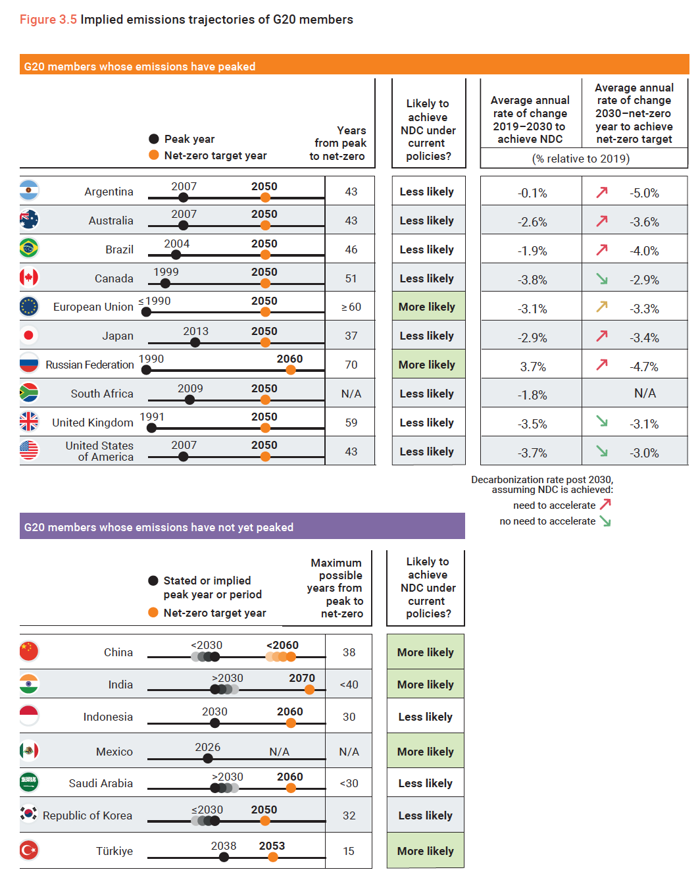

References
[A few recent materials from the authors below]
den Elzen, M. G., Dafnomilis, I., Nascimento, L., Beusen, A., Forsell, N., Gubbels, J., ... & Kuramochi, T. (2025). Uncertainties around net‐zero climate targets have major impact on greenhouse gas emissions projections. Annals of the New York Academy of Science, Volume 1544, Issue 1, February 2025, Pages 209-222, https://doi.org/10.1111/nyas.15285
Harmsen, M., Fragkiadakis, D., Fragkos, P., Vu, A., Fazekas, D., de Boer, H. S., ... & van Vuuren, D. (2024). How the Russian–Ukrainian war reshapes the climate policy context. Environmental Research Letters, 19(12), 124088.
Keramidas, K., Fosse, F., Aycart Lazo, F.J., Dowling, P., Garaffa, R., Ordonez, J., Petrovic, S., Russ, P., Schade, B., Schmitz, A., Soria Ramirez, A., van Der Vorst, C. and Weitzel, M., Global Energy and Climate Outlook 2024, European Commission: Joint Research Centre, Publications Office of the European Union, Luxembourg, 2025, https://data.europa.eu/doi/10.2760/9028706 , JRC139986.
Nascimento, L., Scheewel, J-L, Kuramochi, T., Dafnomilis, I., Hooijschuur, E., den Elzen, M., Forsell, N., Gutiérrez, Z.A., Missirliu, A., Woollands, S., Zhang, N., Wong, J., Hagemann, M., Salsabila, N. P., Fekete, H., de Vivero, G., Pelekh, N., Godinho, C., de Villafranca Casas, M. J., Bos, A., Gusti, M. “Progress of major emitters towards climate targets: 2024 Update.” NewClimate Institute, Cologne, Germany, https://newclimate.org/resources/publications/progress-of-major-emitters-towards-climate-targets-2024-update
Nascimento, L., den Elzen, M., Kuramochi, T. and Höhne, N. (2024) The bridge to net zero matters more than the destination. Cologne, Germany. Available at: https://newclimate.org/resources/publications/the-bridge-to-net-zero-matters-more-than-the-destination

